Assignment 1

Prompt

Give me system design, database schema for below process flow
Goal- create a desktop app integrating mailwizz API with my native .exe
Warmup
case1- Mailwizz sending FROM: 50 .com workspace accounts (hosted as delivery servers) TO: 15 test emails employees
case2- Mailwizz sending FROM- 25 SMTP accounts (hosted as delivery servers) TO: 15 test emails employees
case3- Mailwizz sending FROM: 50 .com workspace accounts (hosted as delivery servers) TO: 50 seed gmail.com
case4- Mailwizz sending FROM- 25 SMTP accounts (hosted as delivery servers) TO: 50 seed gmail.com
case5- Mailwizz sending FROM- 25 SMTP accounts TO: 50 .com workspace accounts
case6- Mailwizz sending FROM- 50 .com workspace account TO: 25 SMTP accounts

We will never move warm up mails landed in spam to inbox for 15 test emails employees. Because its a litmus test, in future once the reputation of domain/IP improves then whether warmup mails diretly start moving to inbox? Call it A/B Testing
50 seed gmail.com- We will always move warmup mails to inbox and then manually reply ....or build a strategy around Headless python script (not finalized it, risk assessment on)
Case3 to case6 we will move mails from spam to inbox….obviously then next mails possibly start landing in inbox (because the mailbox got trained that these mails are not spam but genuine). However, it doesn’t mean the warm up is done! Its just a sign that these 50 seeds+ 50 workspace+ 15 employees treat you fine. It doesn’t mean the world treats your domains highly reputed.
1st reply- We DON’T want to track the reply from seeds, and employees to workspace and SMTP whether land into inbox. (case1 to 4). It doesn’t indicate any warmup.
Replies in case of 5 and 6 definitely indicate warmup if reply mails land in inbox.

Track campaign ID, list ID, campaign date, time, campaign name, list name....mailwizz customer name....sent, delivered, bounced, deferred, queued, error.....and all other information available in mailwizz analytics (please list for my benifit)
Then the code will connect to outlook (or headless python worker script running continously on a cloud using IMAP/SMTP/Google API) and check 50 seed gmail.com and 15 test emails employees....they will be added each in 2 different outlook profiles
We have a ready python script which reads how many emails landed in spam and how many emails landed in inbox.
i am a non-tech founder as you know. Please guide me in layman, simple language what guidelines should i give to my deveopers for this work?
We have 25 SMTP + 50 .com workspace IDs on mailwizz. We need to know the warmup status not at the aggregate level, but at email ID level....
like, what happened to X, Y, or Z email ID?
Also if 25 smtp are dropped (surrendered, blacklisted, suspended or whatever reason), then we need to option to add/delete option
can you give tentative image of UI of such app?

add mailboxes- what should be the input? CSV file with just one column= Email ID is ok?
alternatively
if we add 10 accounts on mailwizz as delivery servers, then can my app pick up those email IDs in its database? (Because we are connecting to mailwizz API)- just not reading their analytics but have access to delivery servers page

we generally use 3 mailwizz licenses....how to capture all together? Can you buid an image capturing add delete, sync and multipl mailwizz license consideration?

................................................................................................................................................................................

Response

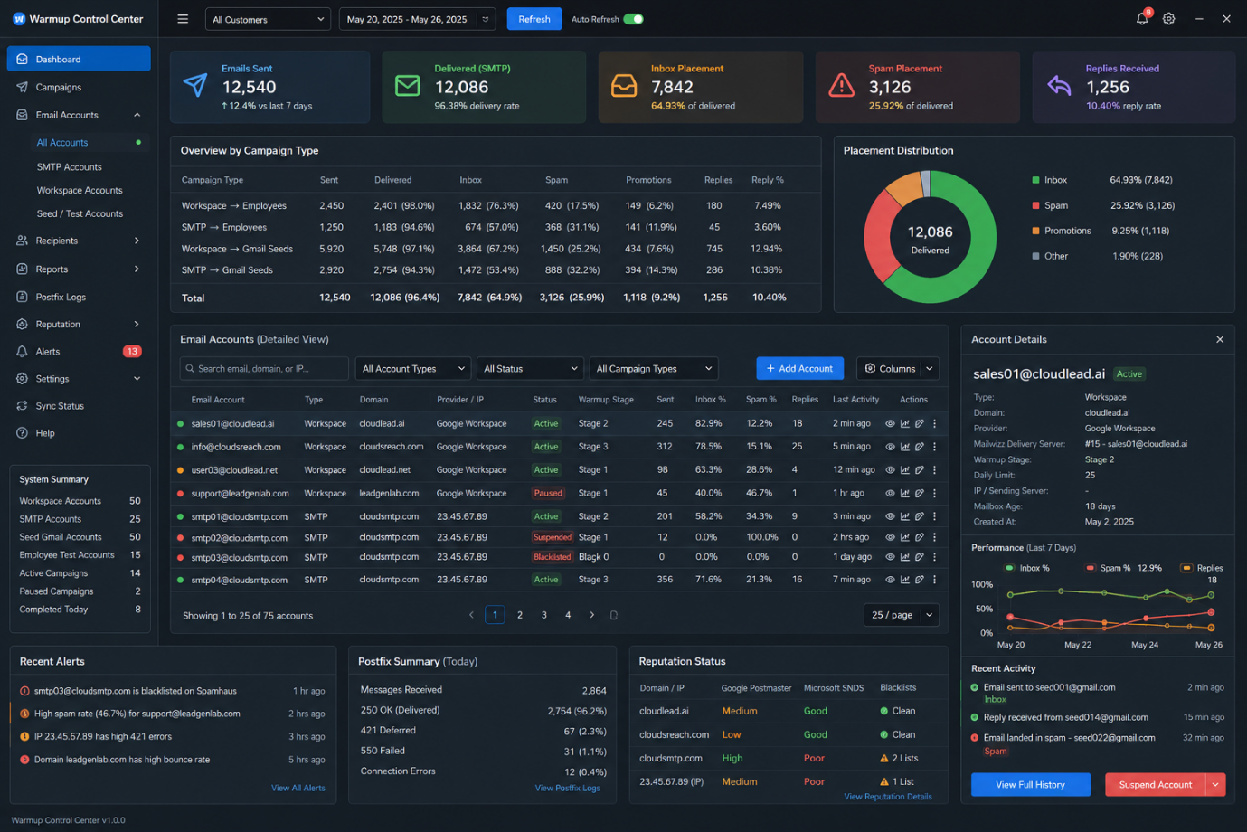

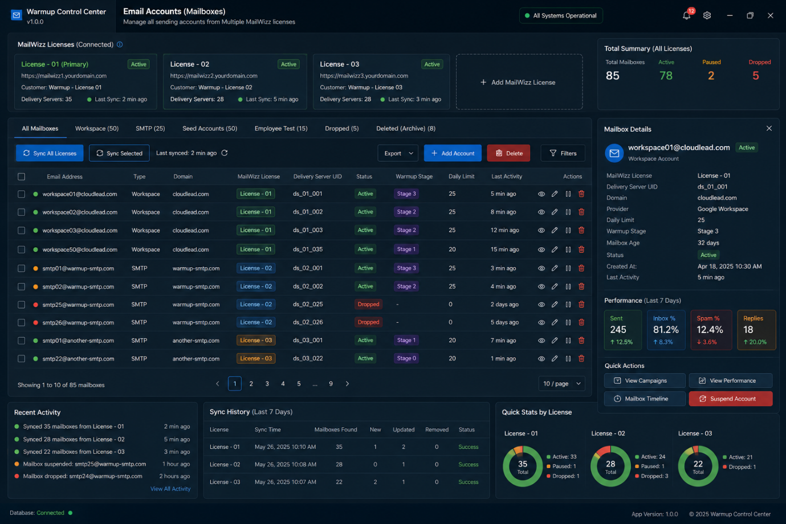

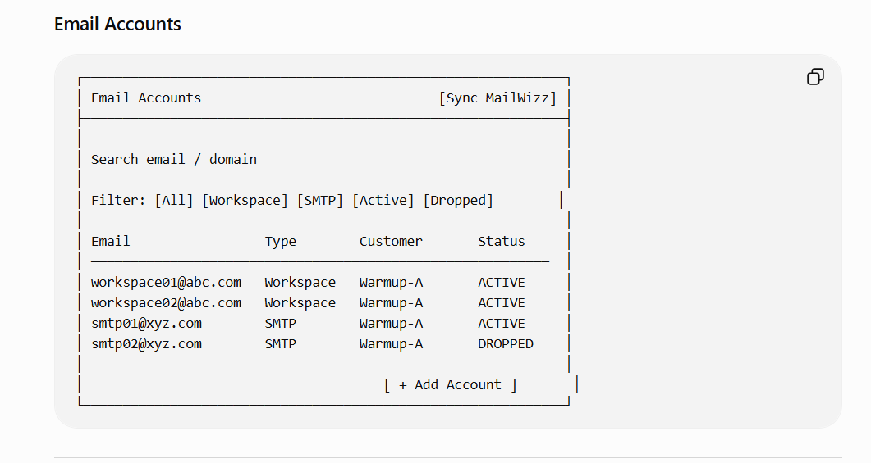

I'll give you a design your developers can build from, and I'll keep the explanation in plain language so you can brief them and judge their work. Let me structure it as: the simple mental model, the database schema, the process flow, the MailWizz data list you asked for, and the plain-English guidelines to hand your team.

The simple mental model (explain this to your devs first)

There are three moving parts, and it helps to name them:

The Sender — MailWizz. It sends the warmup emails and knows what happened on the way out (sent, bounced, deferred). Your app asks MailWizz for this via its API.
The Inbox Checker — your Python worker. It logs into the receiving mailboxes (50 seed Gmails + 15 employee test inboxes) and sees where the email landed (inbox, spam, promotions, missing). MailWizz cannot know this — only the receiving side does.
The Dashboard — your .exe CRM. It stores both halves in one database and shows them together, so you see the full story in one glance.

The key idea: MailWizz tells you the email left; the inbox-checker tells you where it arrived. You need both, joined together, to understand a warmup campaign. Your whole app exists to join those two halves.

Database schema (the tables)

Think of it as a few connected tables. I'll describe each in plain terms, then the fields.

Table 1: mailboxes — the accounts you send FROM (your 50 workspace + 25 SMTP = 75 senders).

mailbox_id (unique)
email_address
type (workspace / smtp)
domain
mailwizz_delivery_server_id (how MailWizz identifies this sender)
mailwizz_customer_name (which customer-group it's clubbed under)
warmup_start_date, daily_cap, status (active/paused)

Table 2: recipients — the accounts you send TO (50 seed Gmail + 15 employee tests = 65).

recipient_id
email_address
type (seed_gmail / employee_test)
move_to_inbox_policy — this is your A/B rule: for employee_test = "never move" (litmus test); for seed_gmail = "always move + reply." Storing it as a field means the logic is data-driven, not hardcoded.
outlook_profile (which of the 2 Outlook profiles it lives in)

Table 3: campaigns — one row per warmup campaign you run.

campaign_id (unique, internal)
mailwizz_campaign_id (MailWizz's own ID)
campaign_name
case_number (1/2/3/4 — your four cases)
from_group (50-workspace / 25-smtp)
to_group (15-employee / 50-seed)
list_id, list_name
mailwizz_customer_name
send_date, send_time
created_at

Table 4: send_events — the SENDING half, one row per email sent (from MailWizz). This is the heart.

send_event_id
campaign_id (links to Table 3)
mailbox_id (which sender — links to Table 1)
recipient_id (which receiver — links to Table 2)
recipient_email
mailwizz_status (sent / delivered / bounced / soft-bounced / hard-bounced / deferred / queued / error / blacklisted)
bounce_reason, error_code (421, 550, 250, etc.)
smtp_response (the raw text MailWizz got back)
sent_at
last_synced_at

Table 5: placement_events — the ARRIVAL half, one row per email the inbox-checker finds. Joined back to send_events.

placement_event_id
send_event_id (links to Table 4 — this join is what unites "sent" with "landed")
recipient_id
folder (inbox / spam / promotions / not_found)
checked_at
moved_to_inbox (yes/no — did the worker move it, per the policy)
replied (yes/no — for seed Gmails)
reply_at

Table 6: reputation_snapshots — your Case 4 (domain/IP health over time).

snapshot_id, domain_or_ip, source (postmaster / mxtoolbox / spamhaus / barracuda), reputation_band (high/med/low/bad), blacklisted (yes/no), checked_at

The magic join: send_events + placement_events on send_event_id gives you, for every single email: who sent it, who got it, whether MailWizz says it left, and where it actually landed. That one joined view is your dashboard.

The process flow (what happens, in order)
You trigger a warmup campaign in MailWizz (Case 1/2/3/4). MailWizz sends the emails.
Your .exe calls the MailWizz API and pulls the sending results → fills send_events (sent/bounced/deferred/etc.). Run this on a refresh button and on a schedule (say every 30-60 min), because bounces/deferrals arrive over time, not instantly.
The Python inbox-checker worker (running continuously on the cloud, or triggered) logs into the 65 receiving mailboxes via IMAP/Gmail API, finds each warmup email, records which folder it's in → fills placement_events.
The policy engine applies your A/B rule: for seed Gmails, move spam→inbox and flag for reply; for employee tests, leave untouched (litmus test). This reads move_to_inbox_policy from Table 2 — never hardcoded.
Case 4 poller checks Postmaster/MXToolbox/Spamhaus every 3-4 days → fills reputation_snapshots.
The dashboard reads the joined data and shows the glance-view.
The MailWizz analytics fields you asked for (what's available to pull)

Via the MailWizz API, per campaign you can typically get: processed/sent count, delivered, bounces (soft and hard, separately), unsubscribes, complaints (abuse/FBL), and — if you didn't strip tracking — opens and clicks. Per-subscriber you get the delivery status and the bounce/error detail. The SMTP-level detail (421/550/deferred/queued/connection errors, the raw server response) lives in the delivery-server logs / Postfix logs, not always the campaign API — which is why your Case 3 Postfix-log parser exists as a separate feed. So: campaign-level counts from the API; granular error codes from the logs. Your dashboard should merge both into send_events.

Since you've turned tracking OFF (correctly, for cold), ignore opens/clicks — they'll be empty or meaningless. Focus your fields on: sent, delivered, soft-bounce, hard-bounce, deferred, queued, error, complaint.

Plain-English guidelines to hand your developers

Here's what I'd literally write in the brief:

"Build it as two feeds into one database." Feed A = MailWizz API (sending results). Feed B = the Python inbox-checker (where mail landed). The app's job is to store both and join them per email. Neither feed alone is enough.
"Every email must be traceable end to end." For any single warmup email, I must be able to see: which mailbox sent it, which recipient got it, what MailWizz reported, and which folder it landed in. That means send_events and placement_events must share a key so they join cleanly. If you can't join them, the design is wrong.
"The inbox-vs-spam number for the 15 employee inboxes is a LITMUS TEST — never move those mails." Store this as a policy field per recipient, not as code. Employee-test mails stay where they land, forever, so we can watch reputation improve over time. Seed Gmail mails get moved to inbox and replied to. Two different policies, driven by a data field.
"Poll on a schedule, not just once." Bounces and deferrals trickle in for hours after sending. Re-sync MailWizz results periodically and update the same rows (don't create duplicates — update by MailWizz's message/subscriber ID).
"Store the raw server response, always." For every bounce/error, keep the exact SMTP text (e.g., '550 5.7.1 blocked') alongside the standardized code. We'll want to categorize later, and you can't recover detail you didn't store.
"Label every placement number by provider and by folder." Gmail vs Outlook separately; Inbox / Promotions / Spam / Not-found separately. Never collapse Promotions into 'inbox' — for us that's a different result.
"Make it idempotent." Running the sync twice must not double-count. Use MailWizz's IDs as the unique key so re-syncing updates existing rows.
"One glance view." The main screen shows, per campaign: sent / delivered / bounced / deferred (from Feed A) and inbox / spam / promotions / not-found split by provider (from Feed B), plus reply count. That single row is the whole point of the app.
One honest note, briefly

This is well-scoped and your devs can build it. Two reminders so it stays proportionate:

This dashboard measures the warmup, which is box-1 infrastructure — a threshold, not a lever. Build it lean enough to answer "is any mailbox degrading, is my placement trend holding." Don't let it balloon into a multi-week project. You just got 2 real leads; the measurement tool must not delay the sending that produces more.
The seed/employee inbox numbers are still directional (they're your own mailboxes, not real prospects). Useful for trend, but the truth remains real-prospect replies. Make sure the dashboard labels them as internal-test signals, so nobody reads "95% inbox to seeds" as "95% to prospects."

Build the two feeds, join them on a shared key, drive the move/reply logic from a policy field, keep the raw responses, and split every number by provider and folder. That gives you the single-glance warmup view you want — and hand your devs points 1-8 above as the spec.

Your second idea is the better one — and it's not just "also works," it's architecturally cleaner. Let me explain why, in plain terms, then tell you exactly what to build.
The problem with CSV (one column = Email ID): a bare email address isn't enough for your app to actually do anything with that mailbox. To show a mailbox in your dashboard and pull its data, your app needs to know: which MailWizz delivery server this email maps to (so it can fetch that mailbox's sending stats), what type it is (workspace/SMTP), and eventually the IMAP/API credentials for the inbox-checker to read where mail landed. A CSV of just emails gives you the label but none of the plumbing — you'd then have to manually match each email to its MailWizz delivery server by hand. For 10 that's tedious; for 600 it's unworkable and error-prone.
Why "read it from MailWizz" is the right answer: MailWizz already holds all of this. When you added those 10 accounts as delivery servers, MailWizz stored — for each one — the delivery server ID, the from-email, the hostname, the type (SMTP/Gmail/etc.), and which customer it's grouped under. The MailWizz API can list delivery servers, not just campaign analytics. So your app should call that endpoint and pull the mailboxes automatically — no CSV, no manual entry. You add a mailbox once, in MailWizz (where you have to add it anyway to send from it), and your app discovers it.
This gives you a principle worth stating to your devs plainly: MailWizz is the single source of truth for "which mailboxes exist." Your app syncs from it; it doesn't maintain a separate list. One place to add a mailbox (MailWizz), one place it flows from (the API). No duplication, no drift, no two lists that disagree.
So here's how "Add mailbox" should actually work:
The button in your app shouldn't be a form where you type an email or upload a CSV. It should be a "Sync from MailWizz" button. When clicked:
- Your app calls the MailWizz delivery-servers API endpoint.
- It gets back the list of all delivery servers (your 75 today, or 85 after you add 10 more).
- It compares against what's already in your database:
  - New ones (in MailWizz, not yet in your DB) → add them, start at Day 1, status = active.
  - Existing ones → leave as-is (don't overwrite their history).
  - Missing ones (in your DB, gone from MailWizz — you deleted the delivery server) → mark them status = dropped, keep their history, grey them out.
That's the whole flow. Add 10 delivery servers in MailWizz, click "Sync," and your dashboard shows 10 new rows. Drop a blacklisted one in MailWizz, click "Sync," and it greys out. Adding and removing both happen by syncing from MailWizz — your app just mirrors reality.
The one thing MailWizz's API does NOT give you, that you'll still need to add per mailbox: the credentials for the inbox-checker to read where mail landed — but note, that's for the receiving side (your 50 seed Gmails + 15 test inboxes), not the sending mailboxes. The sending mailboxes only need to be discovered (which MailWizz gives you) and measured (MailWizz stats + inbox-checker results). So the sync covers your senders completely. Your seed/test receivers are a small, fixed list (65) that you configure once with IMAP/API access — those you can enter manually or via a small config, since they rarely change.
So, to answer both your questions directly:
- CSV of just Email IDs? It works as a minimum, but it's the weaker path — you'd be manually re-linking each email to its MailWizz delivery server, and you'd be maintaining two lists that can drift apart. Avoid it.
- Read the mailboxes from MailWizz via API? Yes — this is the right design. Your app can and should pull the delivery-server list from the MailWizz API, not just analytics. "Add mailbox" becomes "Sync from MailWizz," and add/remove/drop all fall out of that one sync automatically.
Tell your devs: "Use the MailWizz delivery-servers API endpoint to discover mailboxes. Sync on demand and on a schedule. New in MailWizz → add; gone from MailWizz → mark dropped, keep history. Never maintain a separate mailbox list or CSV import — MailWizz is the source of truth for senders." Keep a manual "add mailbox" form only as a rare fallback for a sender that somehow isn't in MailWizz — but the default, and the thing that scales to 600, is the sync.
One small forward note: when you eventually move your live cold campaigns off MailWizz onto your own sequencing engine, this same principle carries over — your sequencing engine becomes the source of truth for its mailboxes, and the dashboard syncs from it the same way. So building the "sync from source of truth" pattern now, against MailWizz, is the right muscle to build — it'll transfer directly to your own engine later.

